
Opening Questions

Name: __________________________________
Date: _______________ Hour: ______

(Please be sure to answer all questions using complete sentences.)

1. We think that Otzi was buried underneath a mass of ice, but can you find any evidence that a glacier existed in the area?

2. How did Otzi stay so well preserved for over 5000 years?

3. Objects and bodies underneath the ice on mountains generally move downhill over time. (see YouTube video of plane crash in the Alps later). We don't think that Otzi moved very far from the place where he died. Why is this?

The Iceman Task Packet: Opening Questions

The Iceman Task Packet: Opening Questions


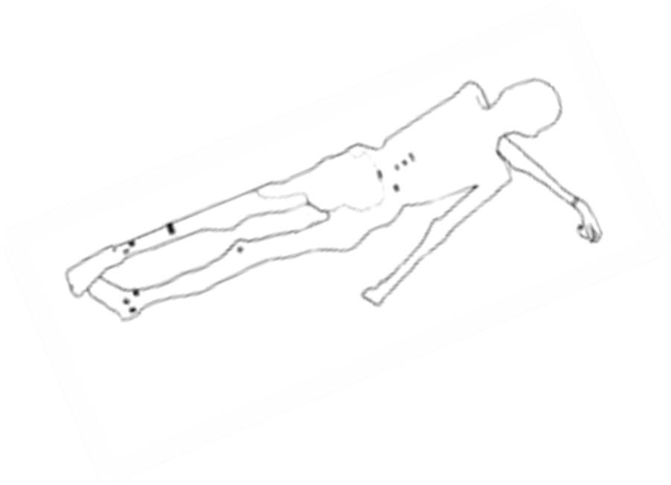
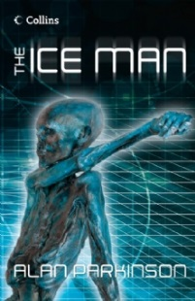
/ //
- Using the Google Map, where exactly was the body found? Make sure you name the country too!
3. Using the picture on page 3, describe the body and sketch the details onto the blank body in the centre of this sheet.
2. Using the Google Earth link, describe the landscape surrounding when the body was found.
4. Witnesses – who found the body? Name & nationality.
5. Is this an unusual occurrence in the part of the world? Why?
Task 1 Hand-out

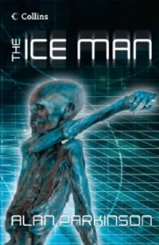
Discovering the Ice Man
Es war ein strahlend sonniger Tag im September 1991, als wir auf dem Weg bergabwärts einen Körper, halb aus dem Eis ragen, entdeckten
Task 2 Hand-out
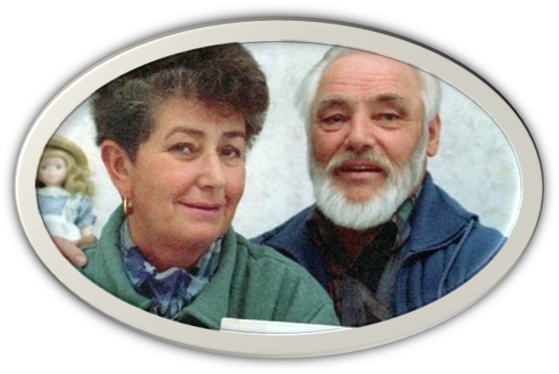

My name is ____________ and this is my wife ________________

Language Test – What are the two people saying above?

September 1991 – Finding the Ice Man – Diary Extract.
Using the map route map (red line) on geographypods, write a diary extract of the two people above. You may want to show off your Geography by studying the landscape carefully and including descriptions of the relief (how steep or flat the land is).
Target. 300 words.

Total Words:

Task 3 Hand-out
Task 3: Burr… its cold up here! - Calculating Temperature

First watch the YouTube video that is mention. Next sole the story problem mentioned using the formula to calculate the temperature. Solve the problem on the Task 3 Hand-out. Show your work and include the correct units.
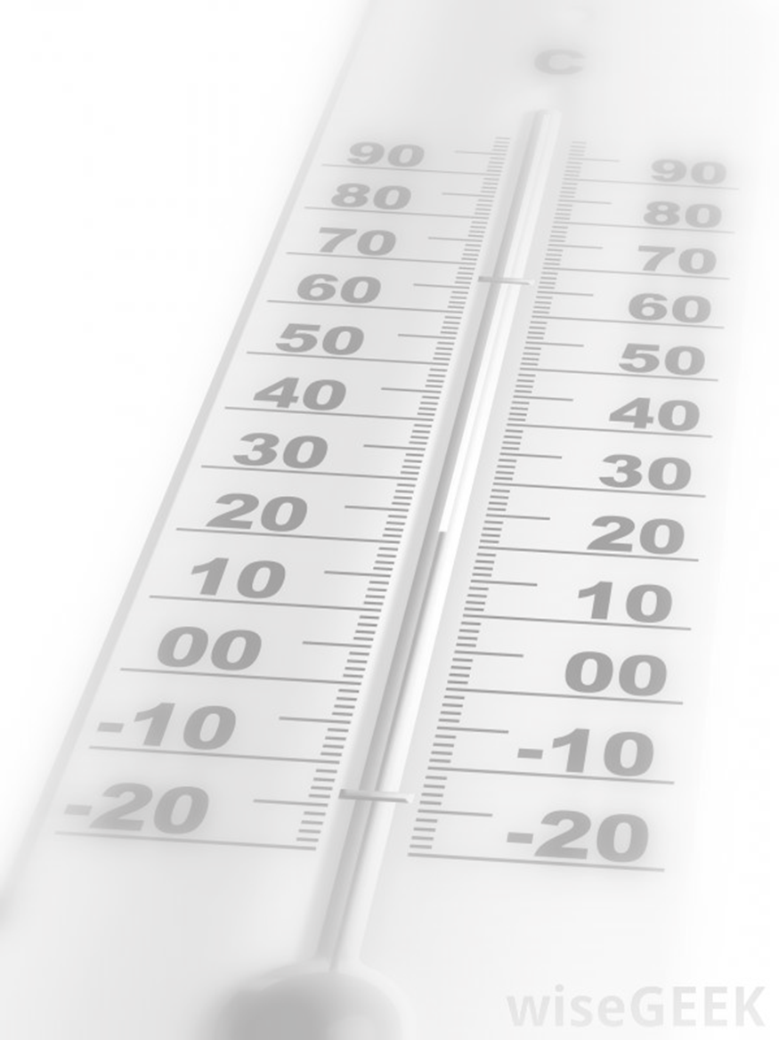

Otzi - An Icy Grave
Task 4 Hand-out

Written Report - Investigators Sheet - Otzi Research Trust (ORT)
Task 5 Hand-out
Question | Evidence | Possible answers / sketches / photos etc
1. We think that Otzi was buried underneath a mass of ice, but can you find any evidence that a glacier existed in the area?

2. How did Otzi stay so well preserved for over 5000 years?

3. Objects and bodies underneath the ice on mountains generally move downhill over time like the WW2 Japanese fighter pilots (see YouTube video later). We don't think that Otzi moved very far. Why?

Task 6 - Ice Man Essay
Question 1. We think that Otzi was buried underneath a mass of ice, but can you find any evidence that a glacier existed in the area?
What do glaciers leave behind them? Can you find any evidence on any of the maps or the Google Satellite view links on this page? Sketches or annotated photos to explain the connection to glaciers is vital to answer this question.
Question 2. How did Otzi stay so well preserved for over 5000 years?
If bodies are buried in the ground, only a skeleton is left after one year in normal conditions. Why was Otzi's body so well preserved? What is the link between altitude, temperature & ice?
Question 3. Objects and bodies underneath the ice on mountains generally move downhill over time. We don't think that Otzi moved very far from the place where he died. Why is this?
This is the most difficult question to answer and will test your knowledge and understanding. Follow these steps:
i. Remember what you saw in the video above? Those pieces of plane wreckage and bodies discovered in 1990, 40 years after the accident, but 2000 metres further down the mountainside
ii. Then look carefully at the photo on page 4 & 5 of the Ice Man book. The body was found in a gully. Does this give you any clues? Also study the very rough hand drawn plan to show how Otzi could have been covered in ice by clicking on the blue tab below.
Please answer these questions in a well-organized essay which includes good transitions between questions.


