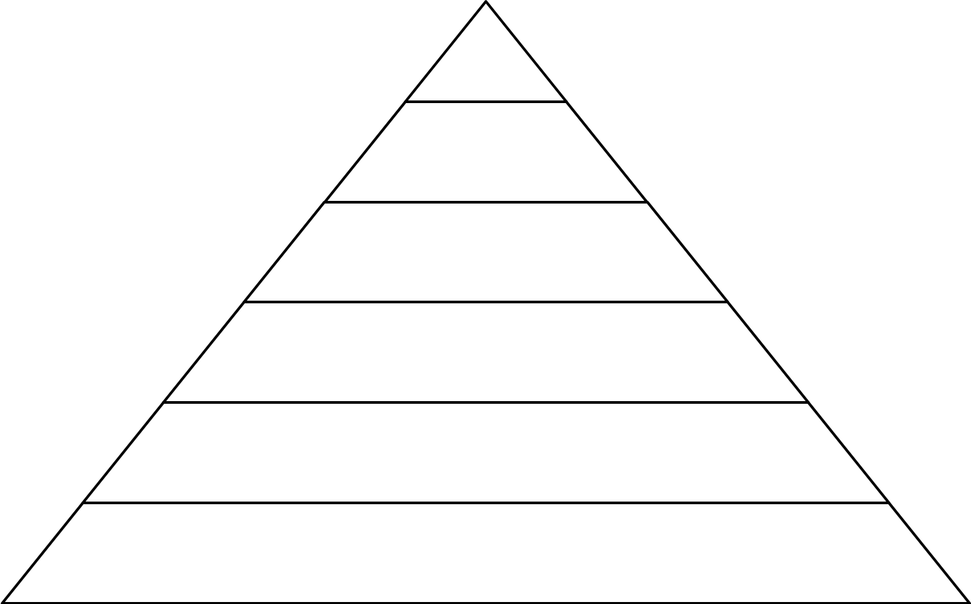Social Hierarchy in the Roman Empire

Emperors:
- Absolute ruler of the ________________…lived in style in the best _________, eating the best __________ and wearing the best ___________. He had lots of ____________ and ___________.
- The emperor’s family lived the life of the ________ and ____________…they spent time with favorite pastimes, like music, poetry, hunting, and horse racing.
- Emperors were not chosen on the basis of their ability or ______________, but simply because they were born in the ________________________.
- But there was still drama…the throne could be passed to _____________, stepsons, or even favored courtiers, and sometimes heirs had to be approved by the ____________. As a result, royal palaces were constantly filled with political plots and _____________.
Patricians:
- Ranked just ________ the emperor and his relatives, the patrician families ___________ Rome and its empire. These families provided the empire’s ____________, _____________, and _____________ leadership.
- Most patricians were _________________________ from old families, but the class was open to a chosen few who had been deliberately ________________ by the emperor.
- They were ______________ as young men for leadership, learning poetry and literature, history and geography.
- The patrician class enjoyed special _____________: its members were excused from some _______________ duties expected of other citizens, and only patricians could become _______________.
- Being a patrician carried its own ___________: patricians could find themselves becoming wrapped up in palace _______ for power. If they lost, they could lose their __________ and even their _________.
Senators:
- The Roman Senate started as an ________________________, filled entirely with ______________, when Rome was under ________. By the last two centuries of the republic, however, it had become much more powerful and a major player in politics and government.
- Once Rome became an empire, senators held much ________ power than they did in the past, although the Senate still had some _______________ power, and occasionally decided who would become emperor.
- This alone ensured that the Senate and its members remained _______________ and _________________.

Equestrians:
- Ranking immediately below senators, equestrians became an important ______________________________, whose work was key to the smooth running of the Roman Empire.
- As its name suggests, the equestrian class was originally composed of the ___________________________. In 218 BCE, equestrians took on more ________________ related roles when Senators were prevented from becoming involved in trade or business.
- As a result, many in the equestrian class became ______________ ____________________. Many were tax collectors, ____________, miners and exporters, while others managed things like road building and ______________.
- Even though they could gain some wealth, they could _________________________________ to become patricians.
Plebeians:
- Rome’s ____________ class, the plebeians had little ______________ power. Grouped together, however, they became a Roman ________ and had to be handled carefully.
- By the first century CE, plebeians comprised a formal class, which held its own meetings, elected its own ____________ and kept its own records.

- The term plebeian referred to all ___________ Roman citizens who were not members of the patrician or equestrian classes.
- Plebeians were average working citizens of Rome – _____________, ____________, builders or craftsmen – who worked hard to support their families and pay their ___________.
Soldiers:
- The Roman Army was one of the most _______________ in the history of the world and its soldiers were rightly feared for their training, discipline, and ____________. As a result, the army was a major player in Roman politics and maintaining its _____________ was important for any Emperor.
- The Roman _______________ – The Roman Empire was created and controlled by its soldiers. At the core of the army its legions, who were highly skilled in their training, discipline, and ________________ ________________.
- The minimum term of service for a soldier during the first century CE was ____________ years.
Freedmen:
- Once freed, former slaves could work in the same jobs as plebeians – as craftsmen, midwives, or ____________. Some even became wealthy.

- However, Rome’s society attached importance to social status and even successful freedmen usually found that their past _______________ was hard to overcome – people in the higher classes still looked down on them and treated them ______________.
Women:
- Defined by the men in their lives, women in ancient Rome were valued mainly as ______________________________. Although some were allowed more freedom than others, there was always a limit, even for the ___________________ of an emperor.
- Not much information exists about Roman women in the first century. Women were not allowed to be active in ______________, so nobody wrote about them. Neither were they taught how to _________, so they could not tell their own stories.
- Legal Rights – Unlike society in ancient Egypt, Rome did not regard women as _________ to men before the law. They received only a basic _______________, if any at all, and were subject to the ___________________ of a man.
Gladiators:
- Successful gladiators were the ____________________ of the first century. Bloody, brutal but popular, gladiator matches are often seen as the dark side of Roman civilization. Gladiators were one particular class of ________________.

- Ceremonial, public violence had been a favorite __________________ of the Romans for centuries. The practice began as an ancient Etruscan ________________ ritual: when a tribal chief died, his warriors would make a blood sacrifice to his spirit by fighting to the death by his tomb.
- This changed over time. The nobility began to put on gladiator shows in memory of the _________ and by the time __________________ was in charge, these exhibitions had become public spectacles.
- Organized games - The games took place in __________________. Gladiators would be sent to the arena to fight to the death before cheering crowds of _________________. As the contests became more organized gladiators became more __________________.
Slaves:
- The most unfortunate slaves were the __________, who were worked often to the point of _________ by their owners.
- Some slaves were a part of the _______________________, or domestic ________________ who worked in the households of more wealthy families.
- Sometimes, enslaved people _______________ and tried to escape.

