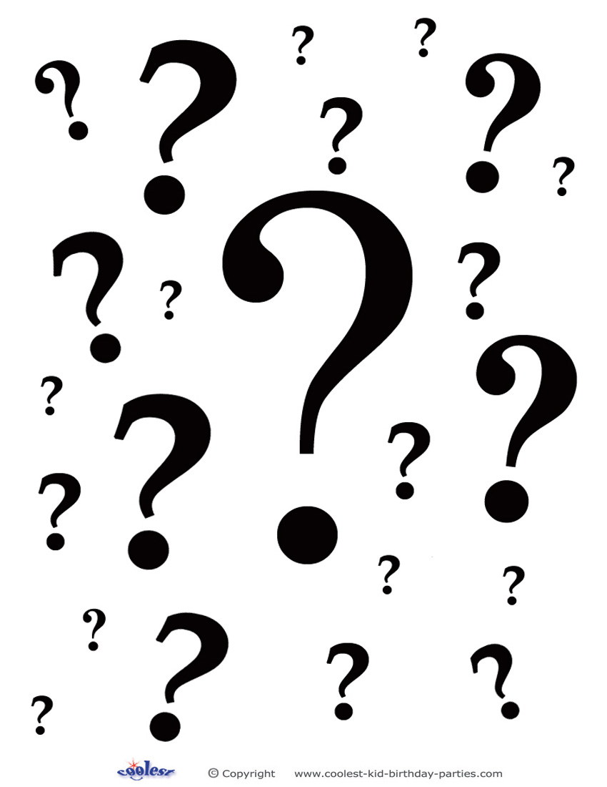
What’s the BIG deal?
Introducing Reading Strategies

- There are a variety of strategies good readers use to help them understand what they read.
- Good readers are metacognitive – they think about what their own thinking while they read.
- Good readers think about what they are reading by summarizing, predicting, questioning, clarifying, and visualizing.
- Good readers connect what they are reading to what they already know or have already experienced.
- Good readers monitor their own understanding as they read and notice confusion.
- Good readers use different strategies when they are confused, such as using context clues to make sense of what they read, re-reading, asking questions, or using textual aids (pictures, tables, glossaries, etc.).

